LAB ASSIGNMENT:01
NAME : CHALLA. Thanu sree
ROLLNO :2403A54109
BATCH :04
Lab 1: Environment Setup – GitHub Copilot and VS Code Integration

Lab Objectives:
- To install and configure GitHub Copilot in Visual Studio Code.

- To explore AI-assisted code generation using GitHub Copilot.

- To analyze the accuracy and effectiveness of Copilot's code suggestions.

- To understand prompt-based programming using comments and code context

Lab Outcomes (LOs):
After completing this lab, students will be able to:

- Set up GitHub Copilot in VS Code successfully.

- Use inline comments and context to generate code with Copilot.

- Evaluate AI-generated code for correctness and readability.

- Compare code suggestions based on different prompts and programming styles.

Task 0
- Install and configure GitHub Copilot in VS Code. Take screenshots of each step.
Expected Output
- Install and configure GitHub Copilot in VS Code. Take screenshots of each step.
- 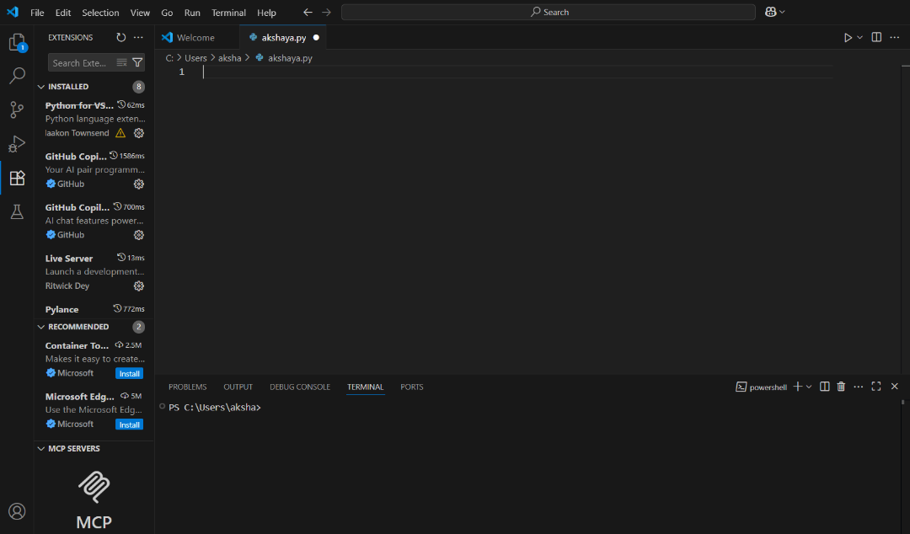

Task 1: Factorial without Functions
- Description:
Use GitHub Copilot to generate a Python program that calculates the factorial of a number without defining any functions (using loops directly in the main code).
- Expected Output:
  - A working program that correctly calculates the factorial for user-provided input.
  - Screenshots of the code generation process.
  - 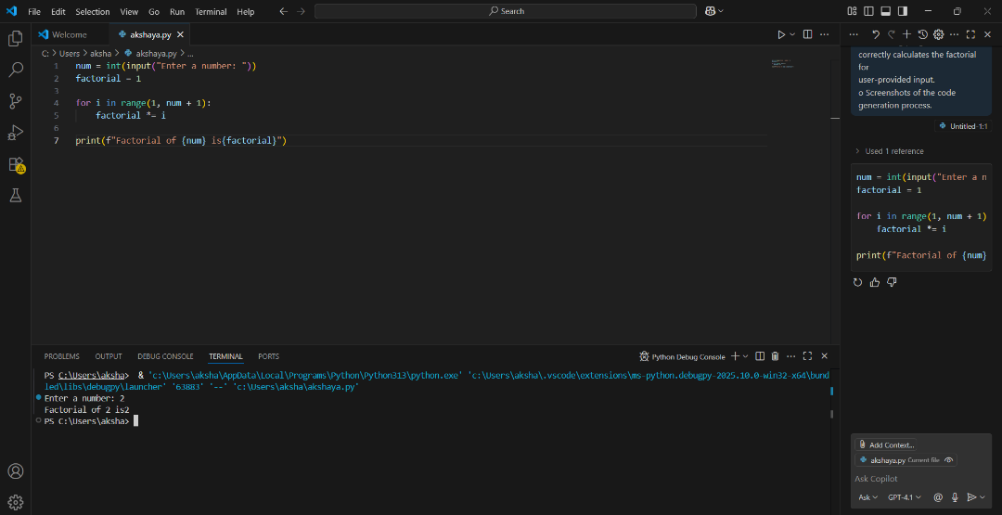

Task 2: Improving Efficiency
- Description:
Examine the Copilot-generated code from Task 1 and demonstrate how its efficiency can be improved (e.g., removing unnecessary variables, optimizing loops).
- Expected Output:
  - Original and improved versions of the code.
  - Explanation of how the improvements enhance performance.
  - 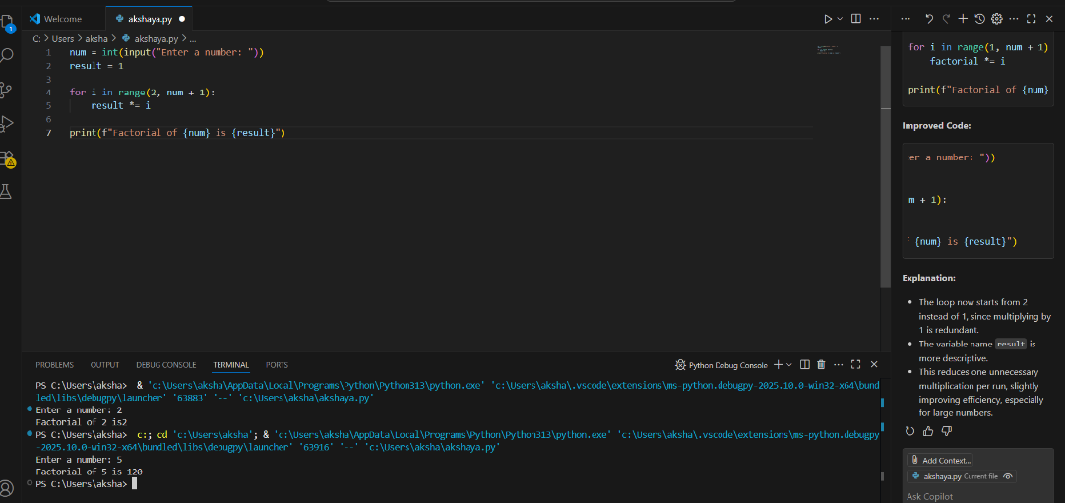

Task 3: Factorial with Functions
- Description:
Use GitHub Copilot to generate a Python program that calculates the factorial of a number using a user-defined function.
- Expected Output:
  - Correctly working factorial function with sample outputs.
  - Documentation of the steps Copilot followed to generate the function.
  - 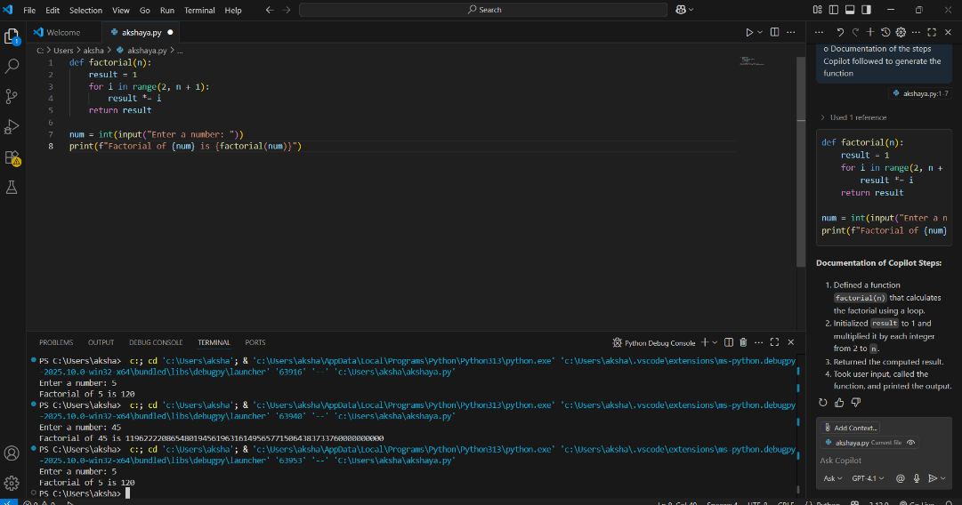

Task 4: Comparative Analysis – With vs Without Functions
- Description:
Differentiate between the Copilot-generated factorial program with functions and without functions in terms of logic, reusability, and execution.
- Expected Output:
  - A comparison table or short report explaining the differences.
  - 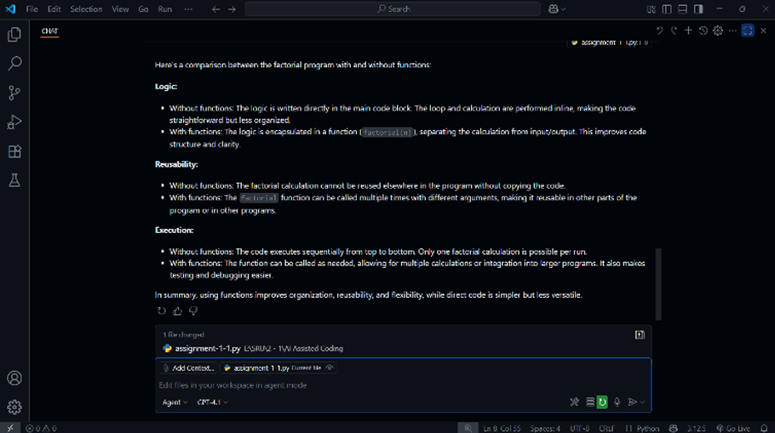

Task 5: Iterative vs Recursive Factorial
- Description:
Prompt GitHub Copilot to generate both iterative and recursive versions of the factorial function.
- Expected Output:
  - Two correct implementations.
  - A documented comparison of logic, performance, and execution flow between iterative and recursive approaches.
  - 